Maven:  
  
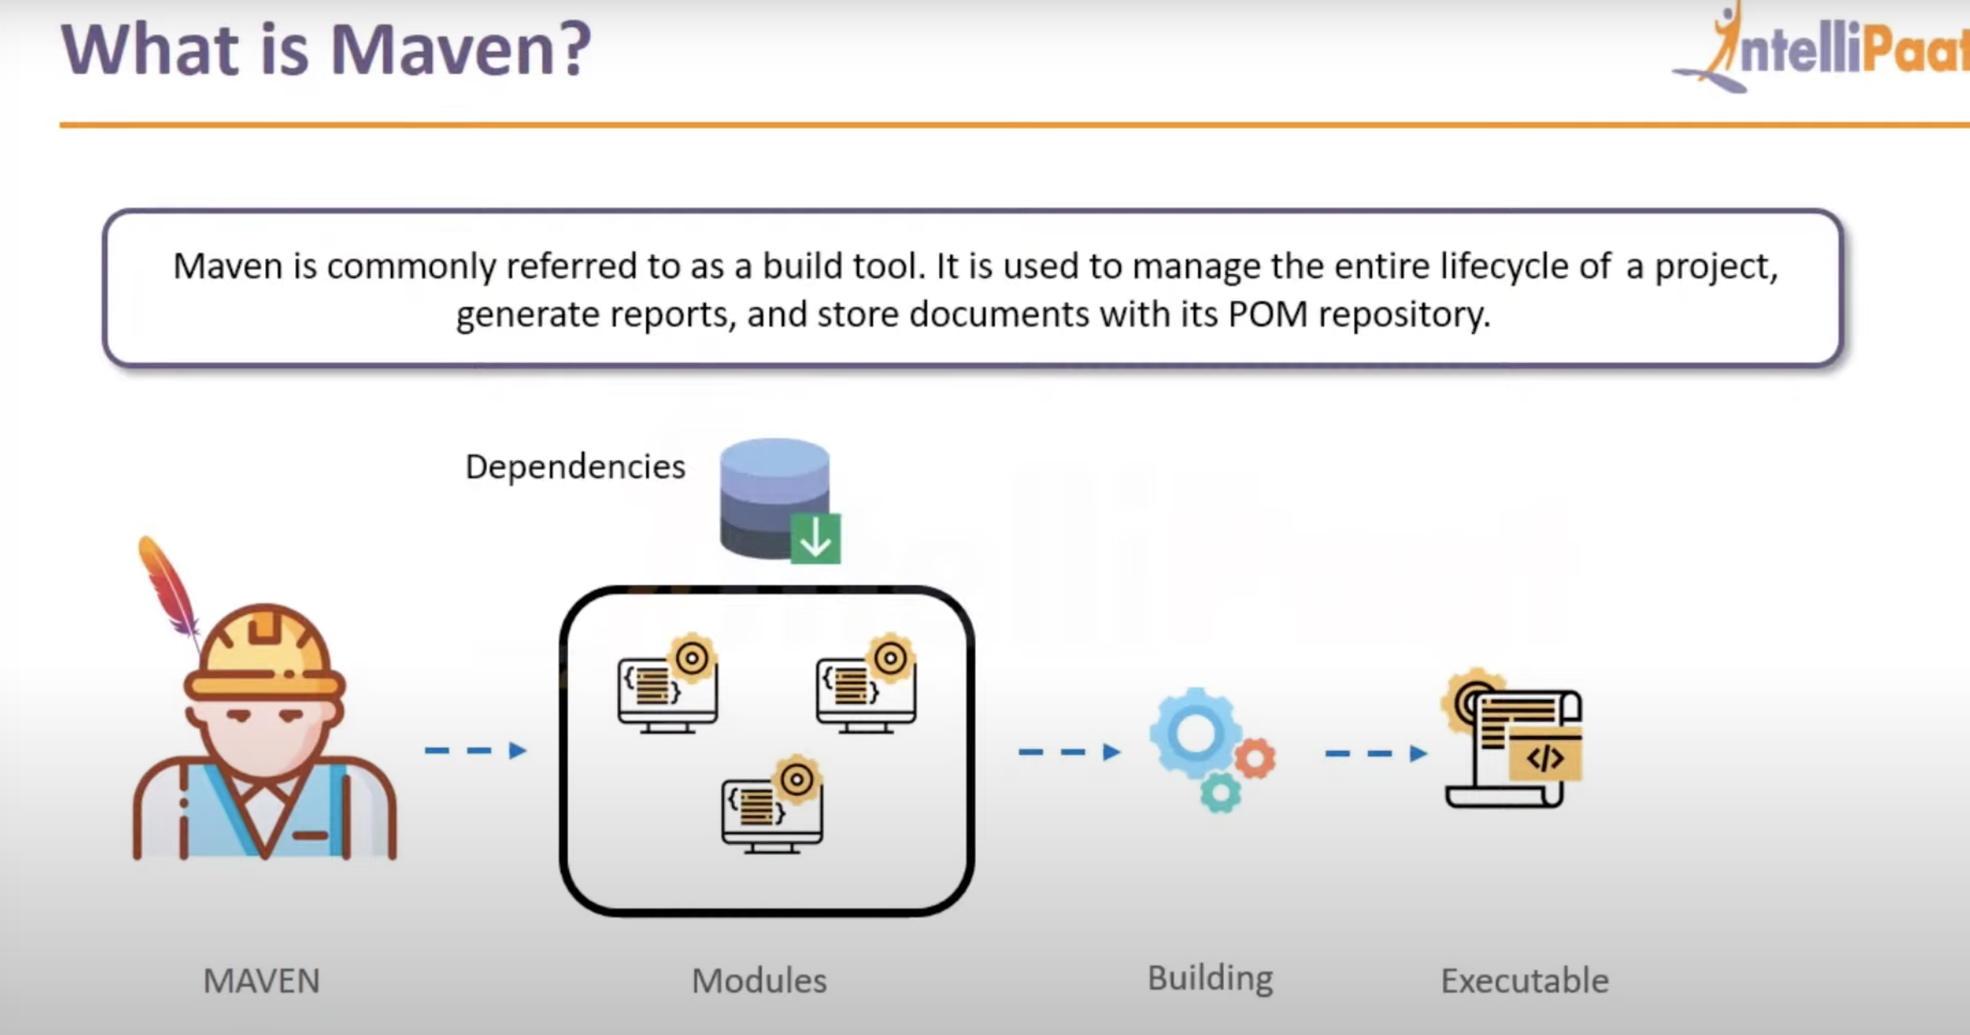

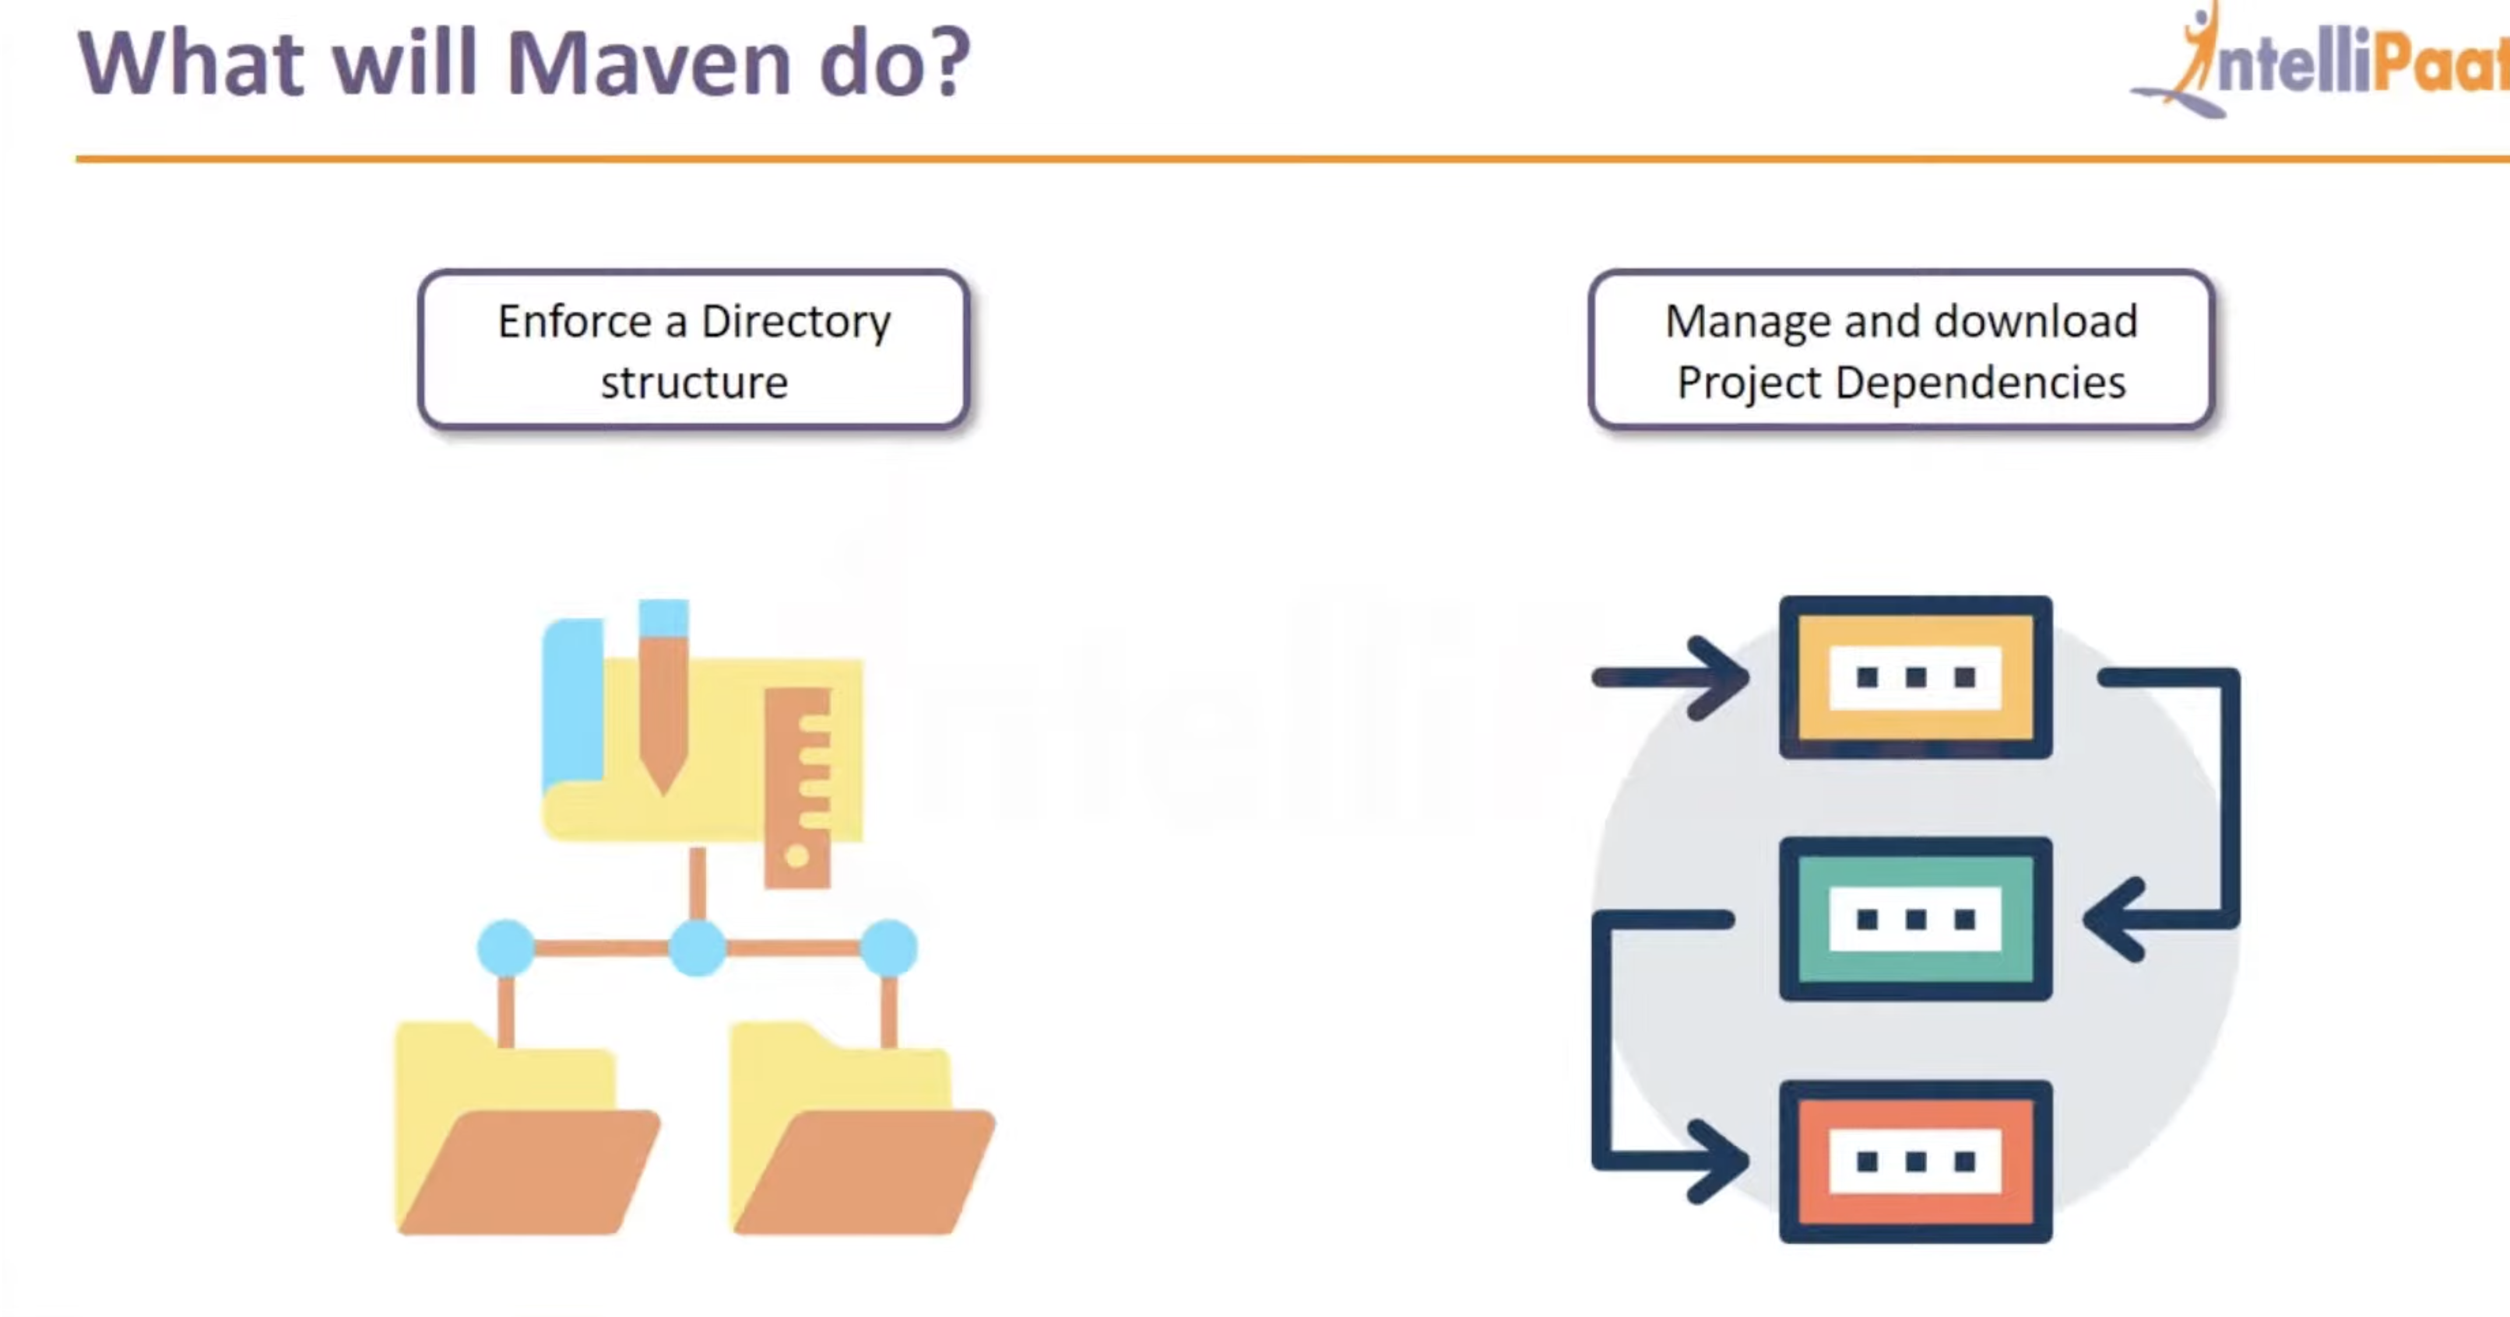

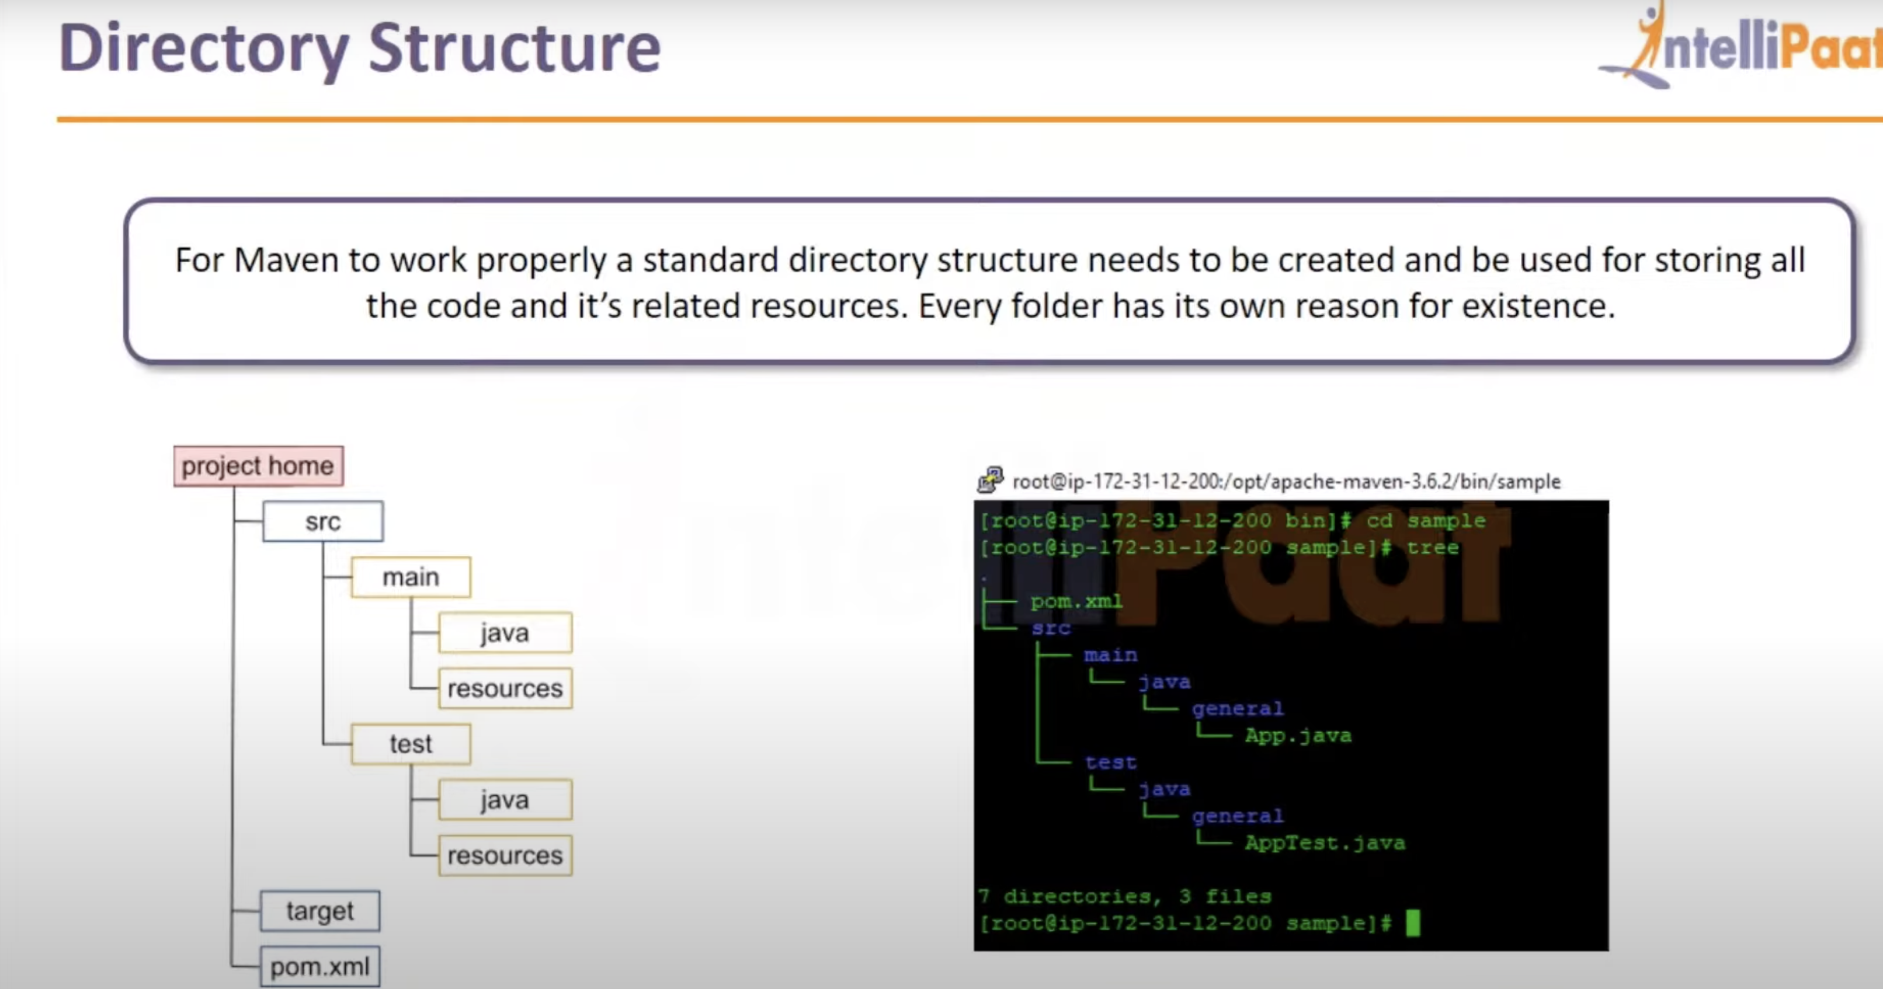

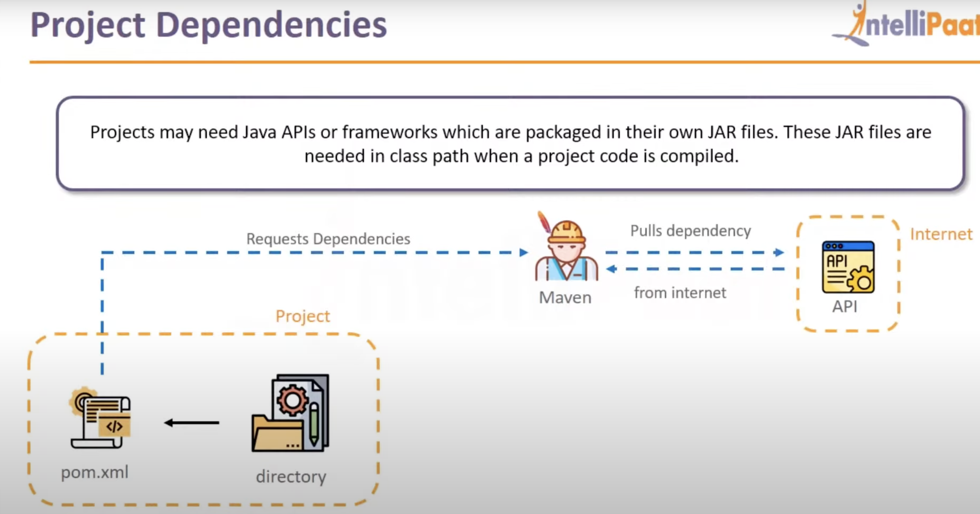

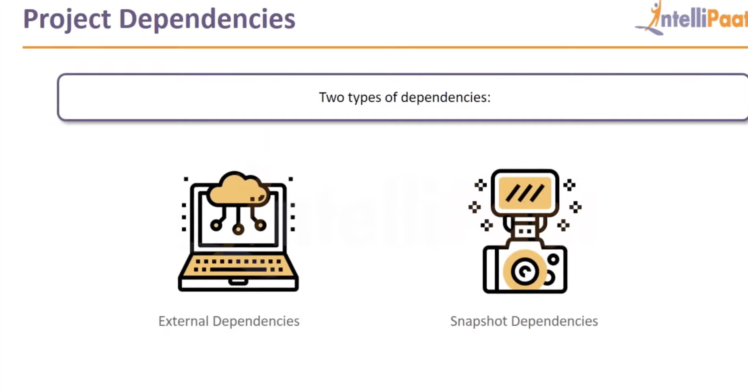

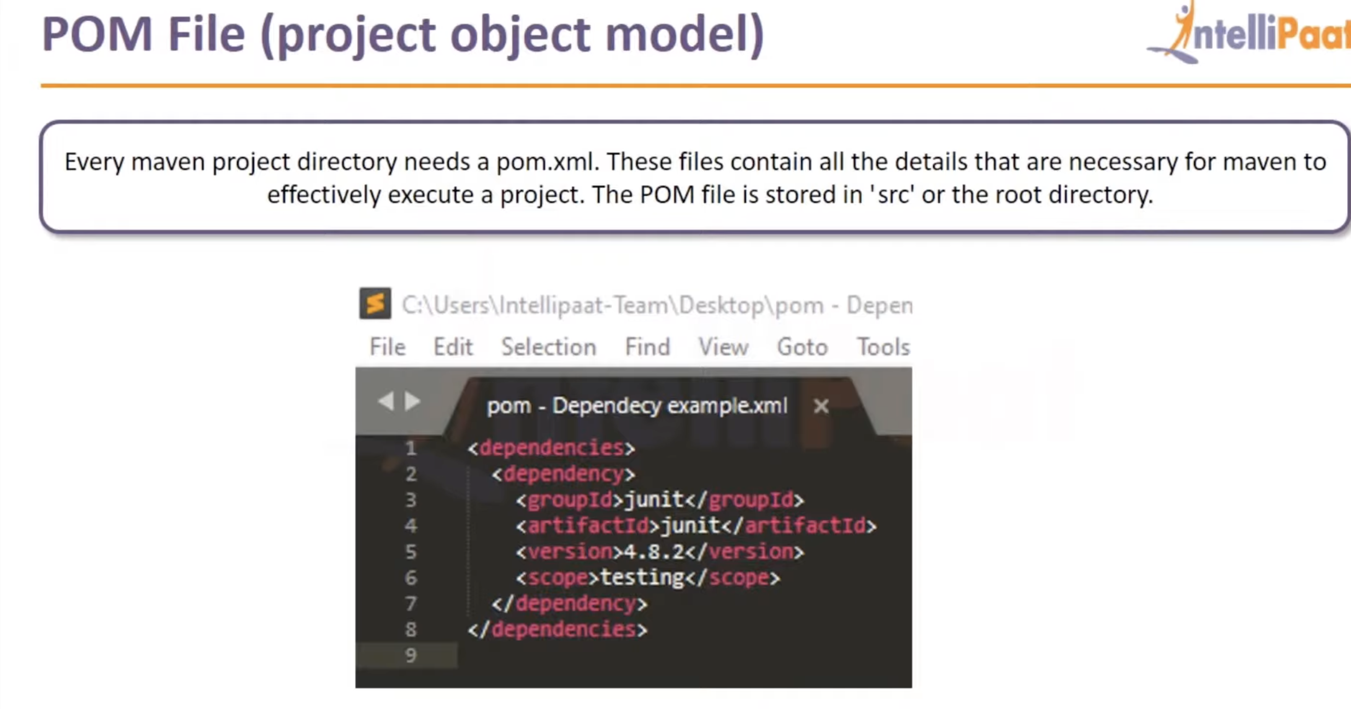

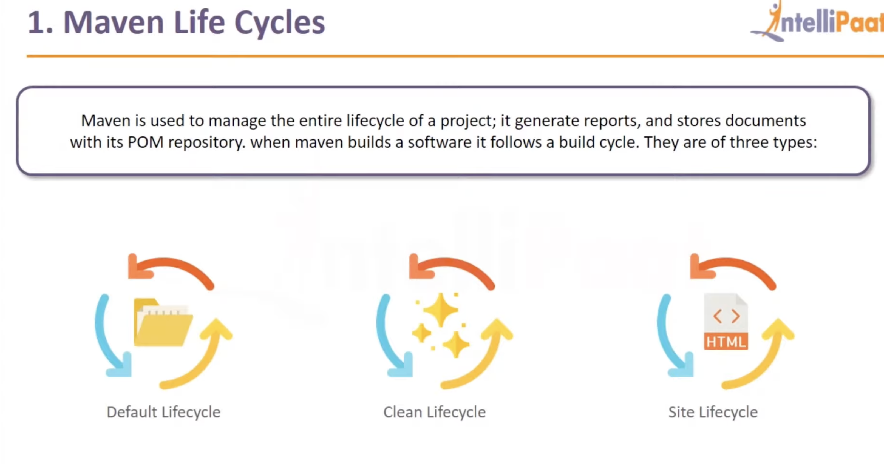

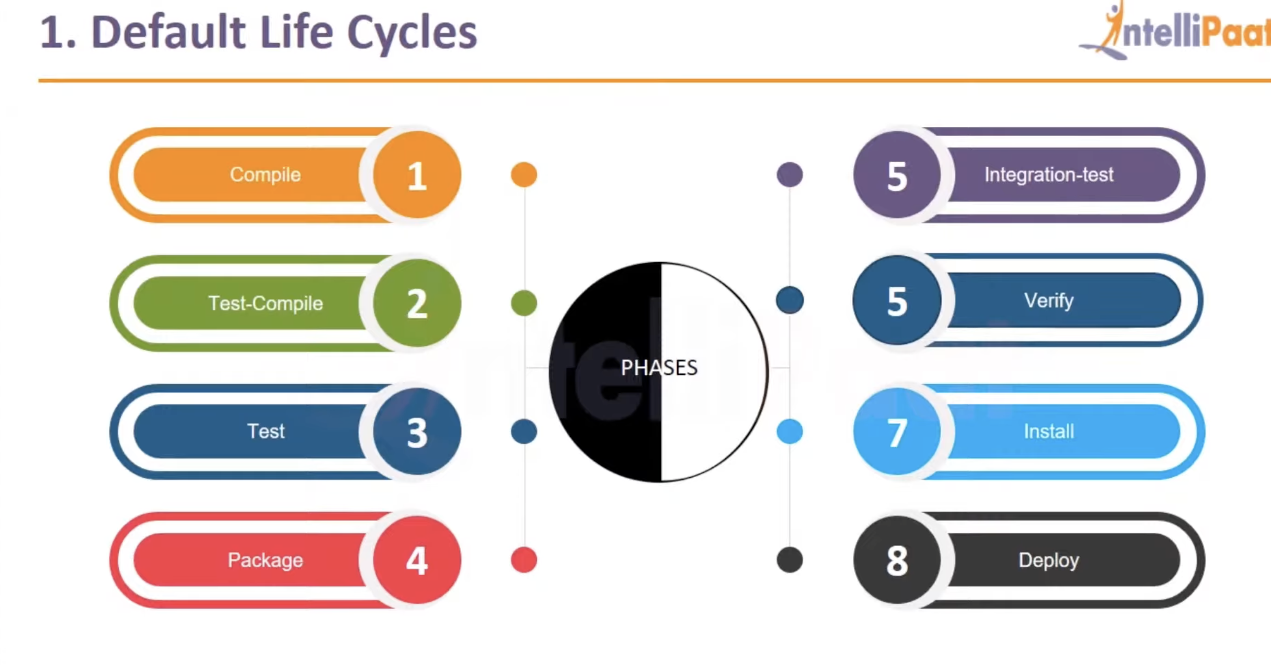

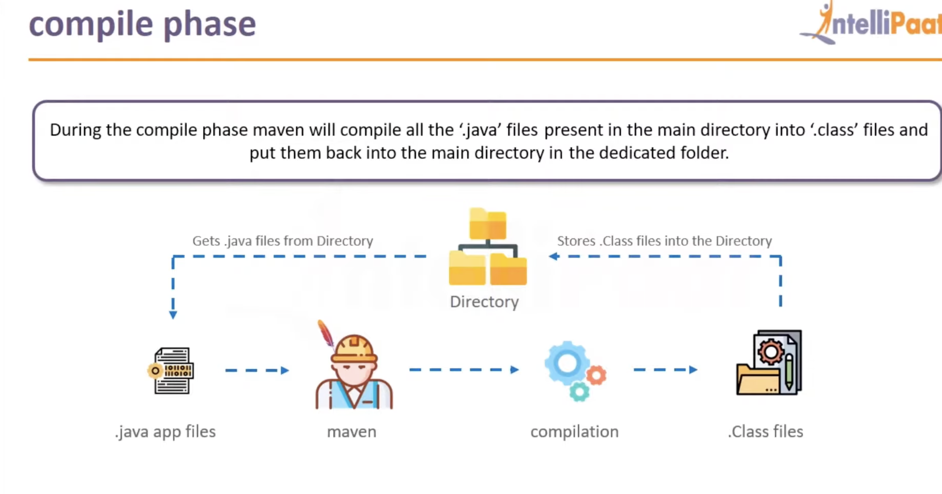

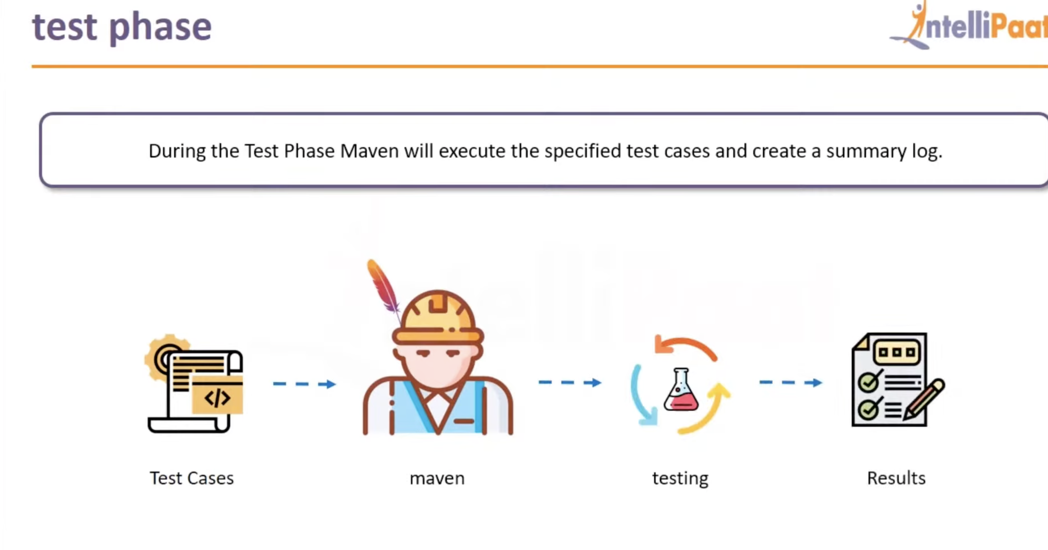

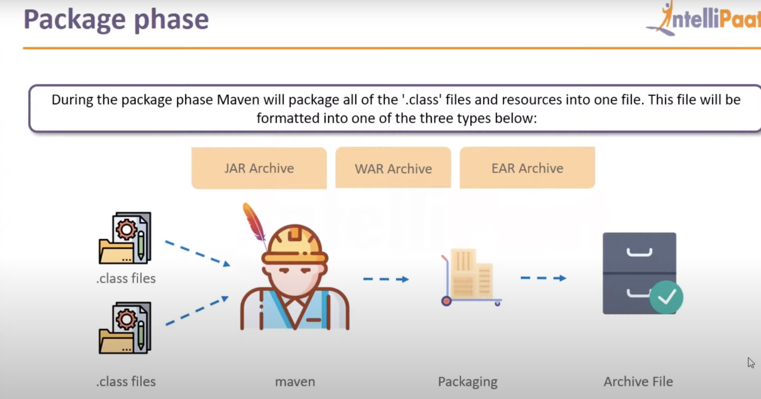

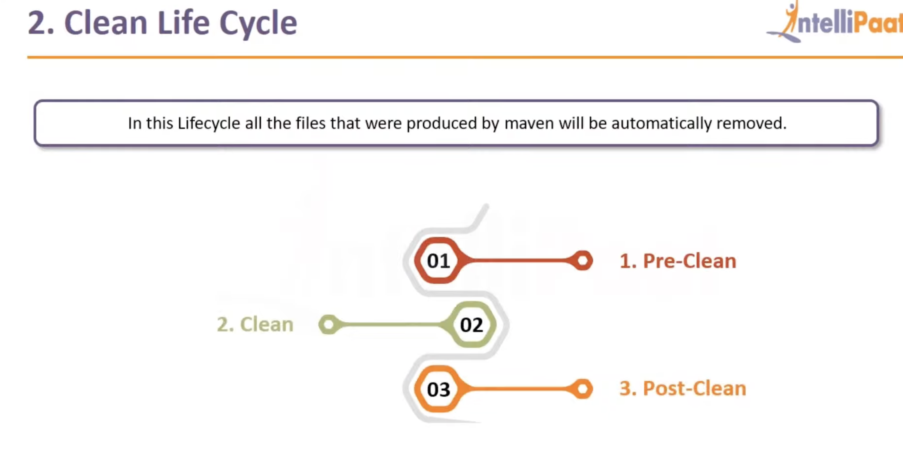

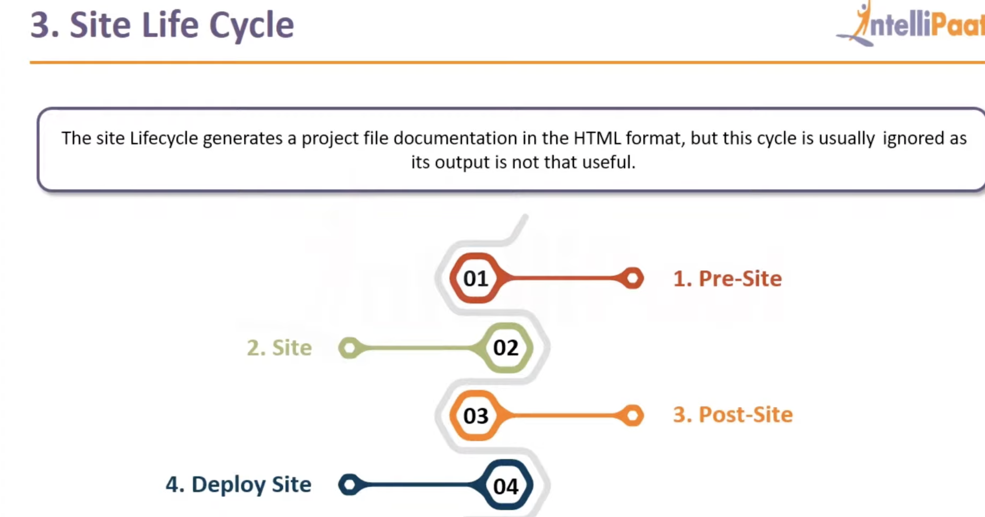

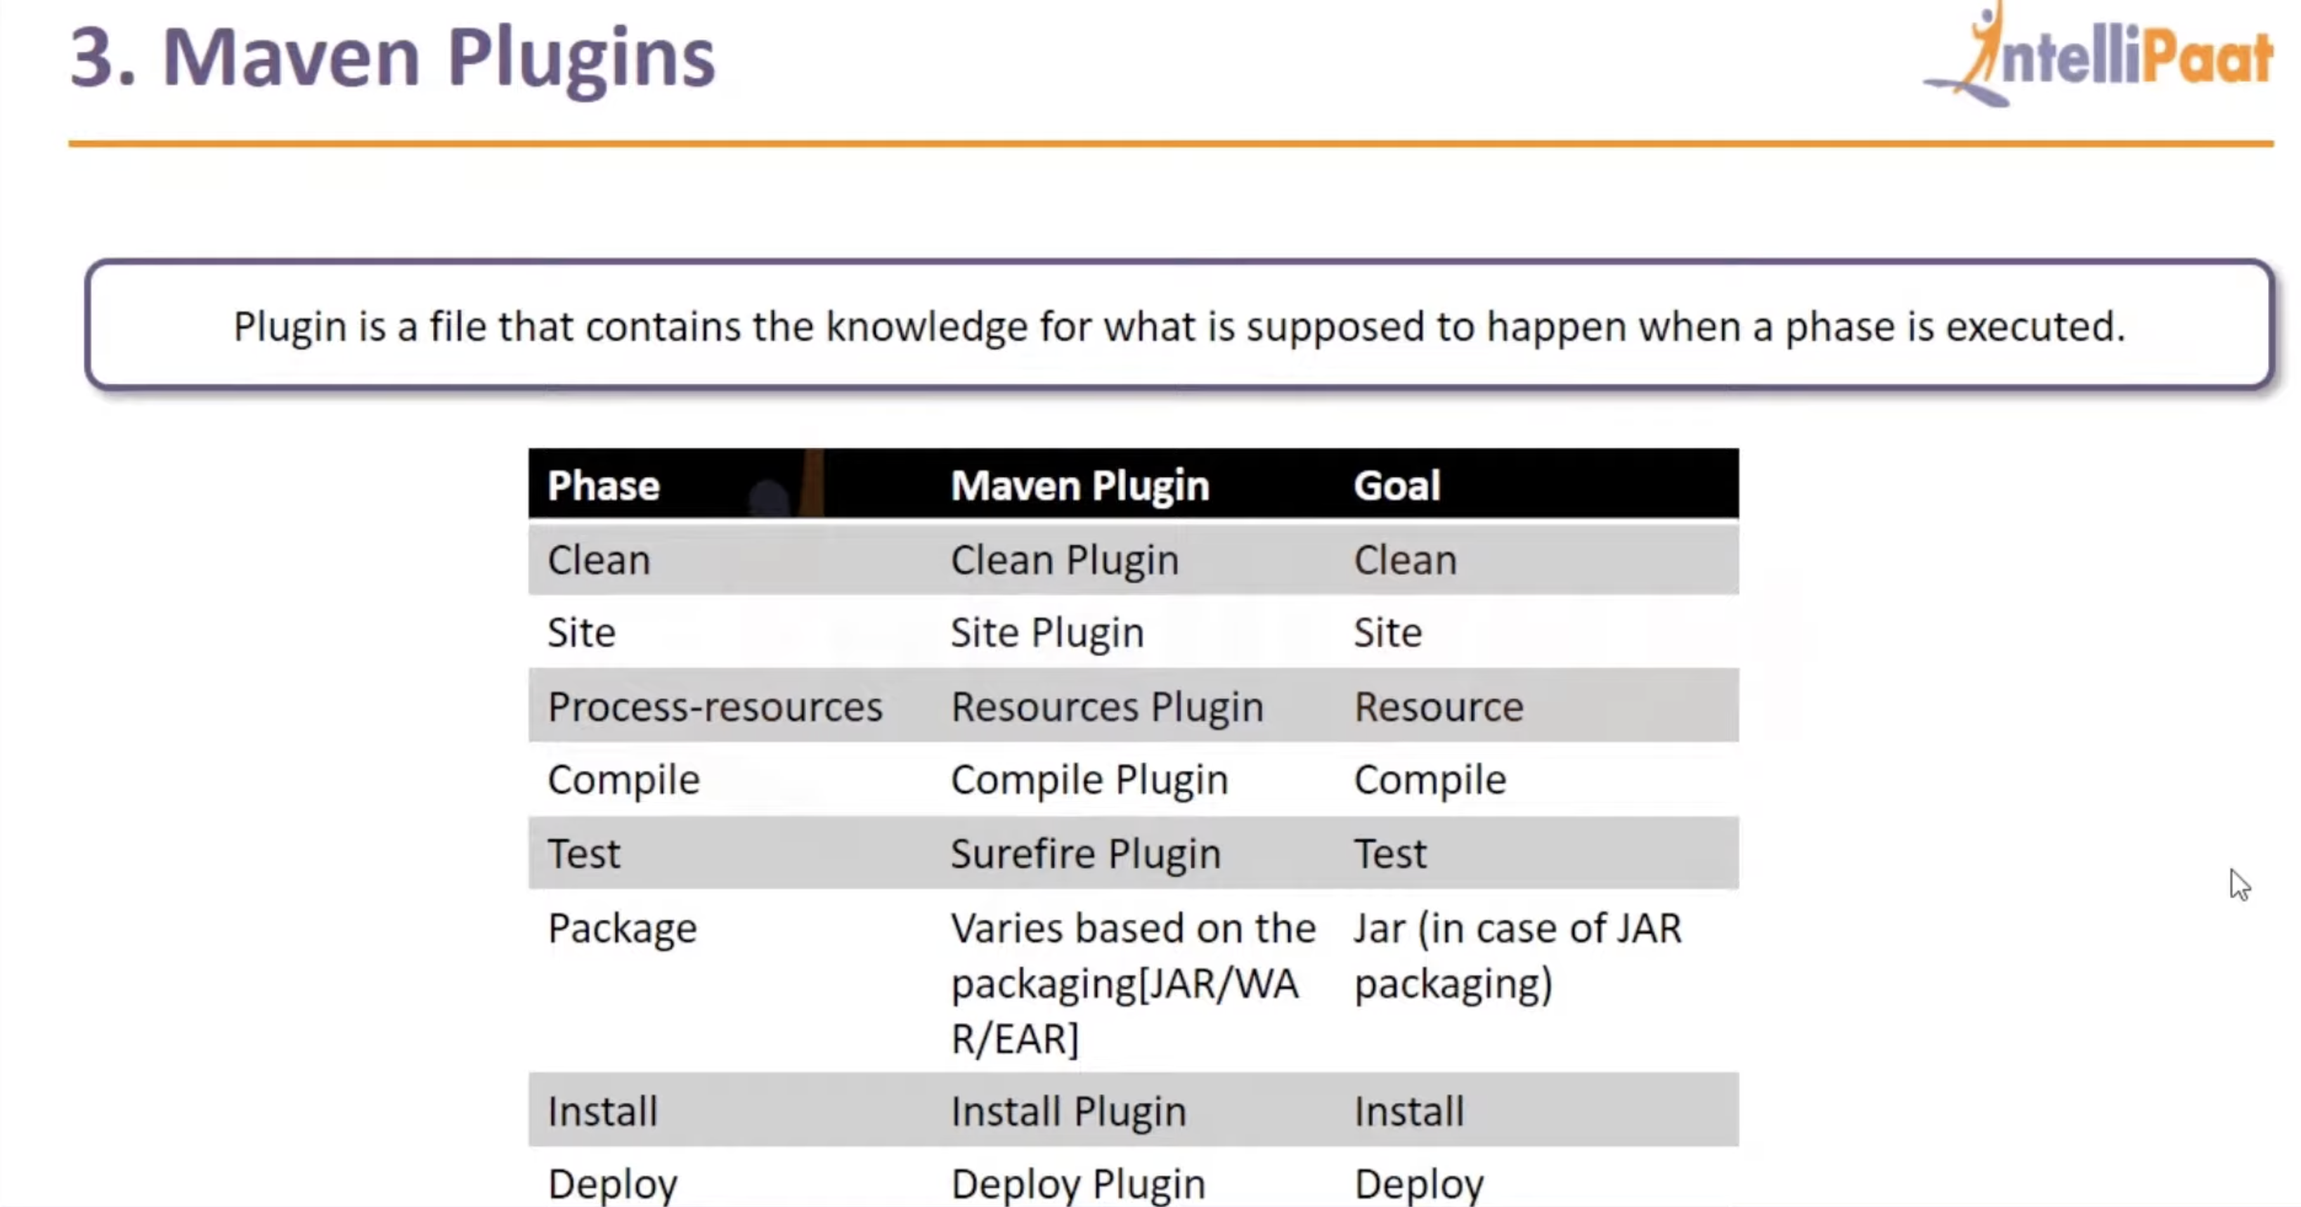

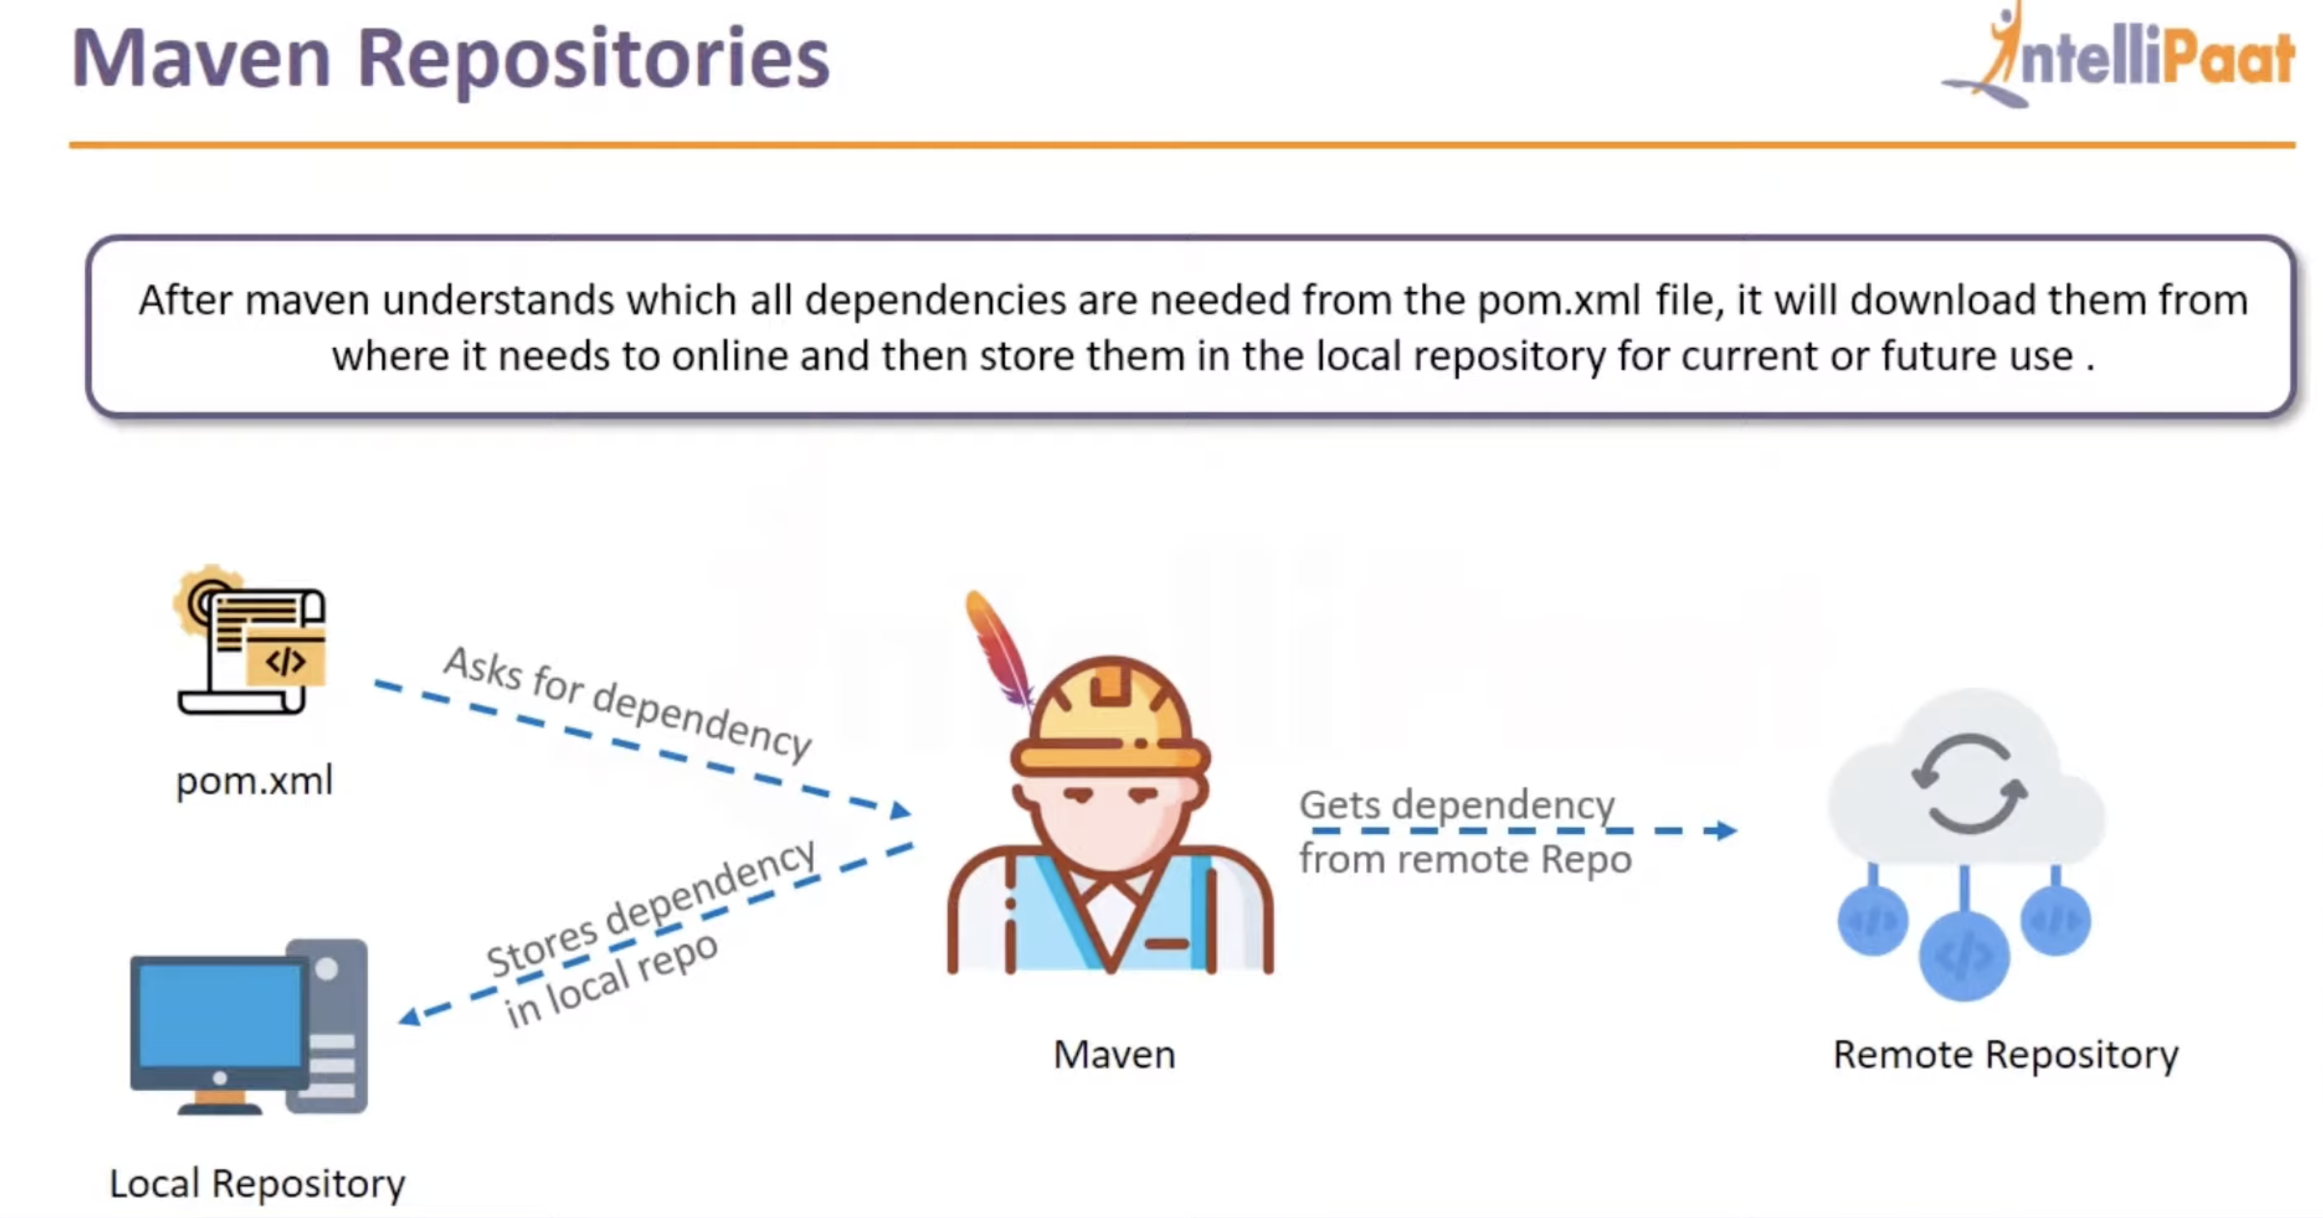

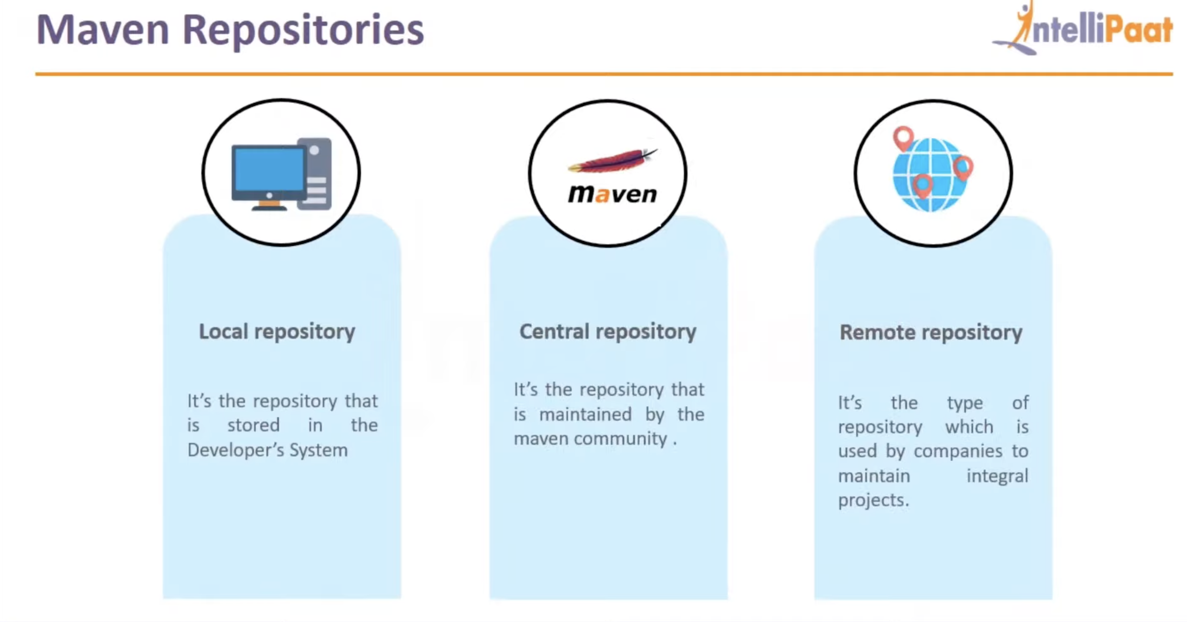

Life cycle:

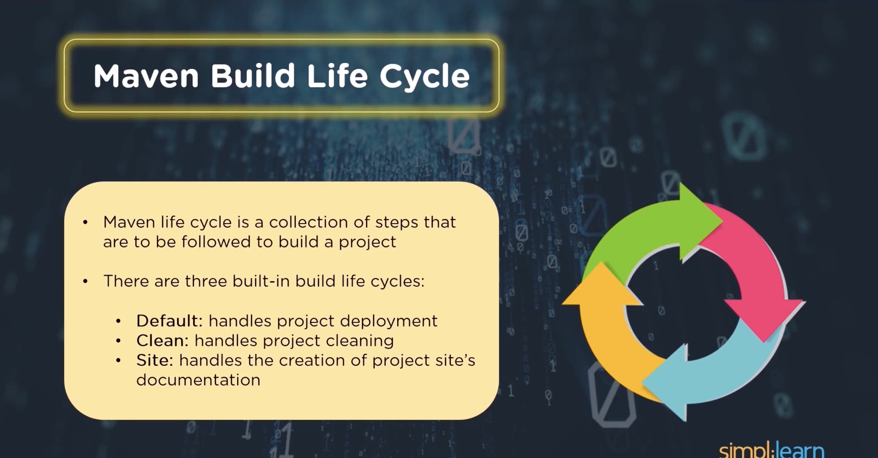

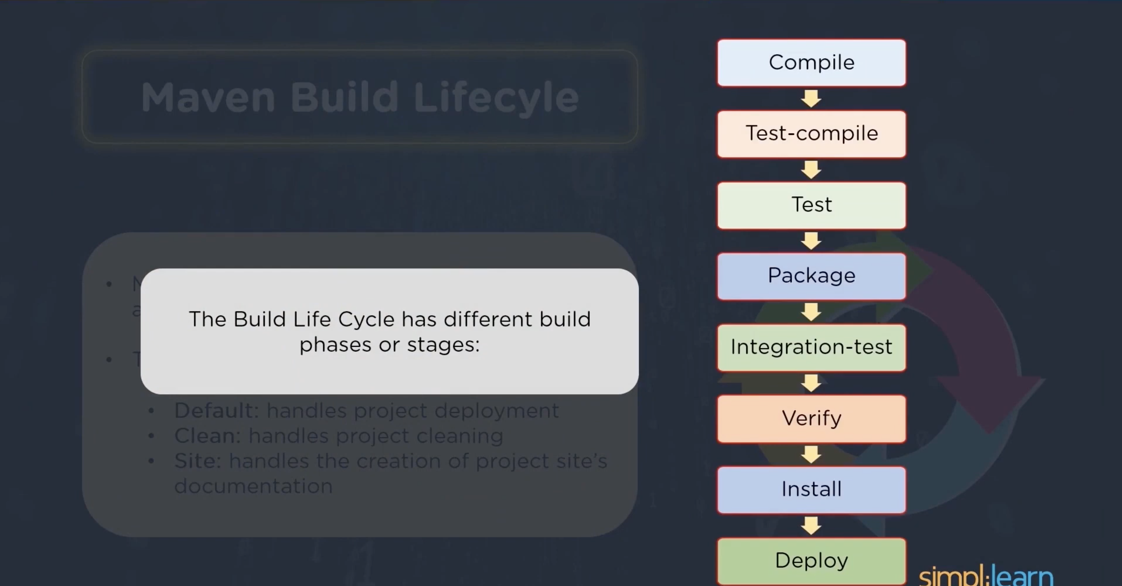

Commands which I tried:

#mvn archetype:generate -DgroupId=testing.dev.app -DartifactId=dev.app -DarchetypeArtifactId=maven-archetype-quickstart -DarchetypeVersion=1.4 -DinteractiveMode=false  
  
drwxrwxr-x 4 granga401 granga401 35 Jul 12 10:37 projects

[granga401@dev ~]$ ll projects/

total 0

drwxrwxr-x 4 granga401 granga401 46 Jul 12 10:41 dev.app

[granga401@dev ~]$ ls -l projects/dev.app/

total 4

-rw-rw-r-- 1 granga401 granga401 2653 Jul 12 10:37 pom.xml

drwxrwxr-x 4 granga401 granga401 30 Jul 12 10:37 src

drwxrwxr-x 9 granga401 granga401 194 Jul 12 10:42 target

Maven Project inheritance

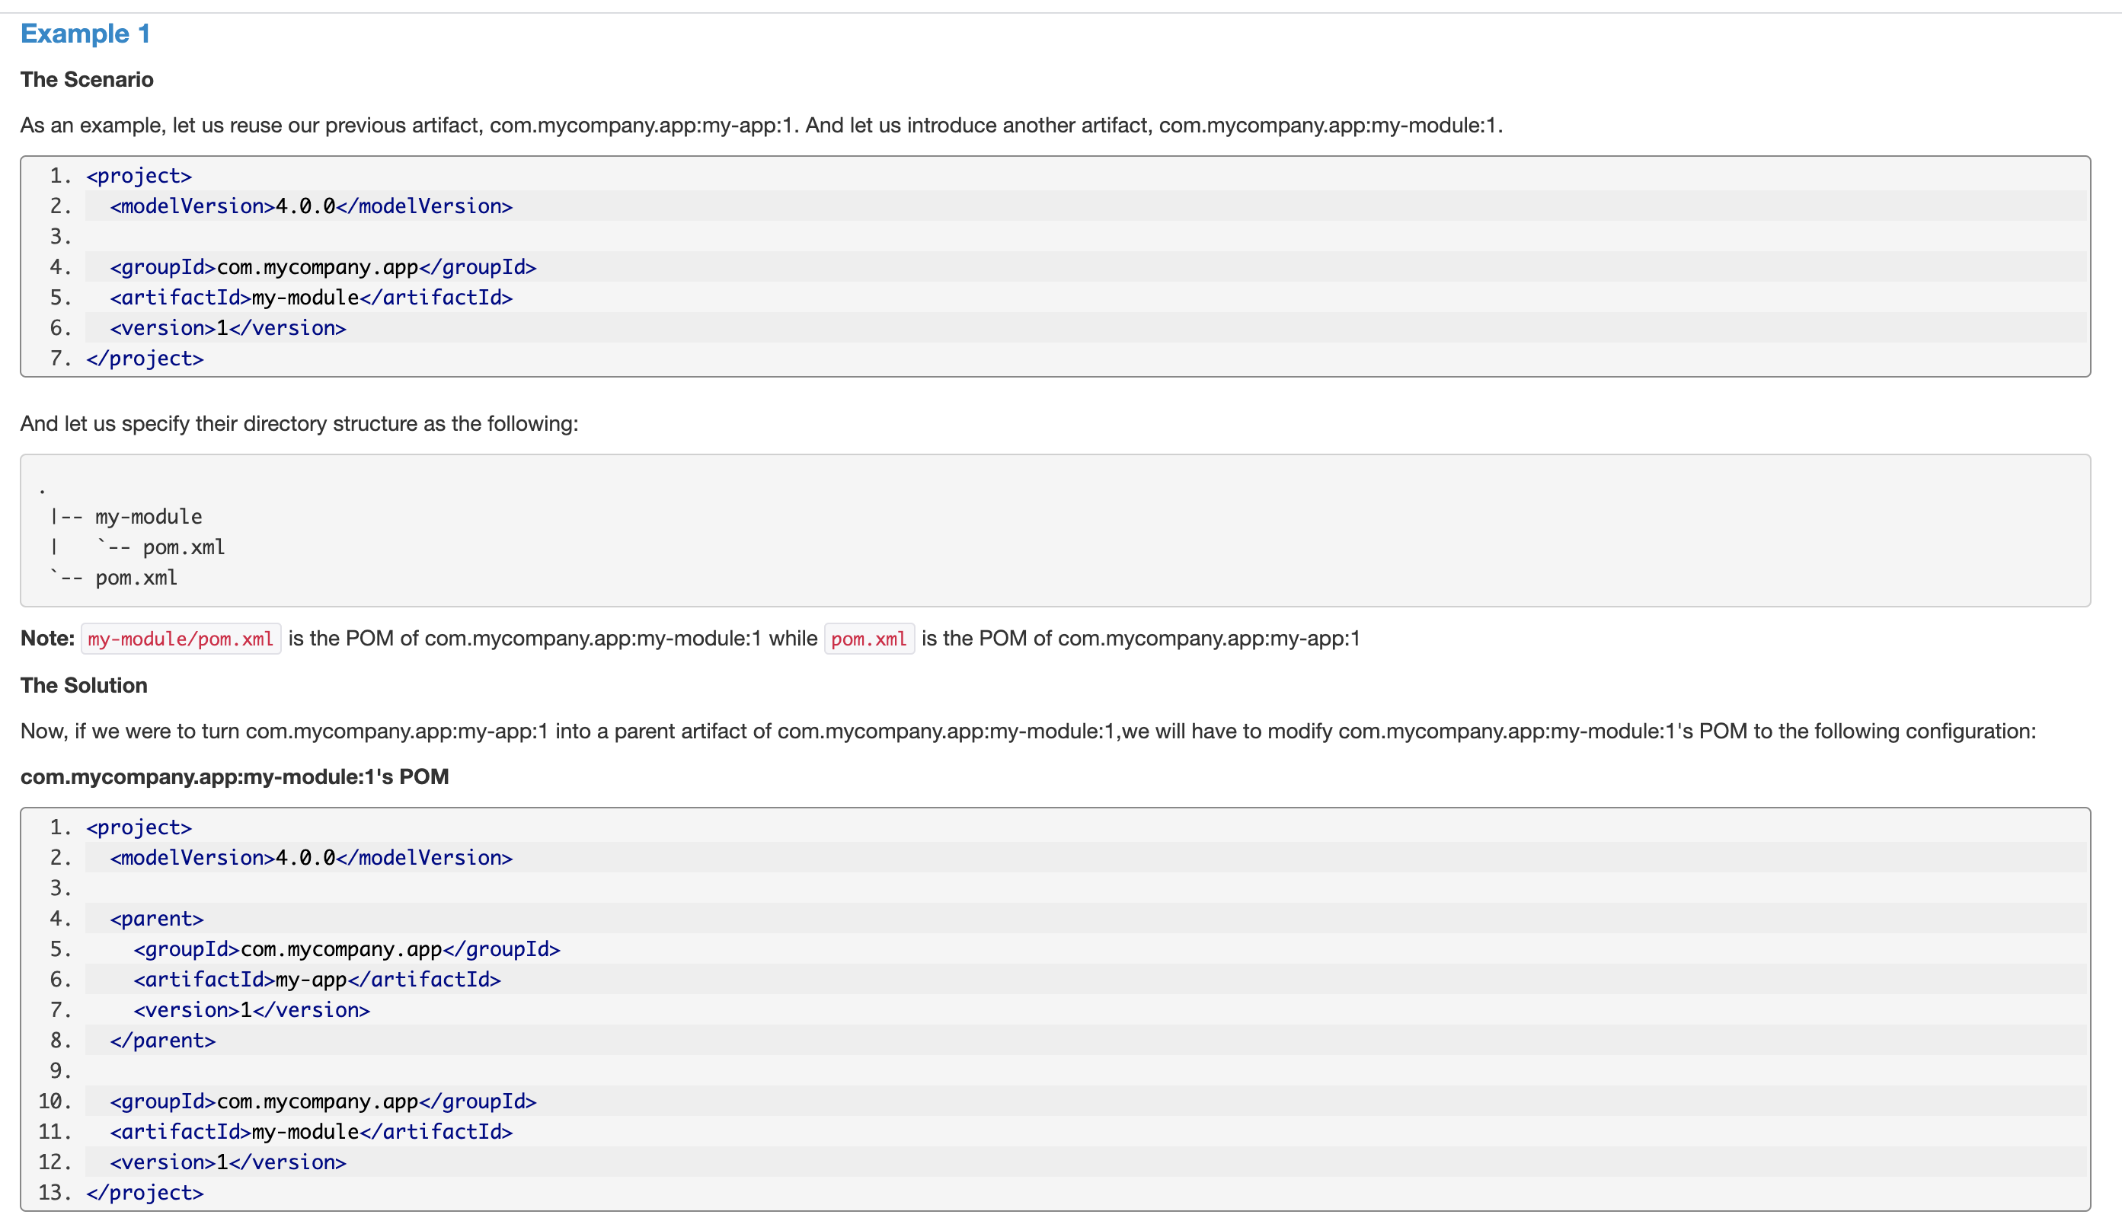

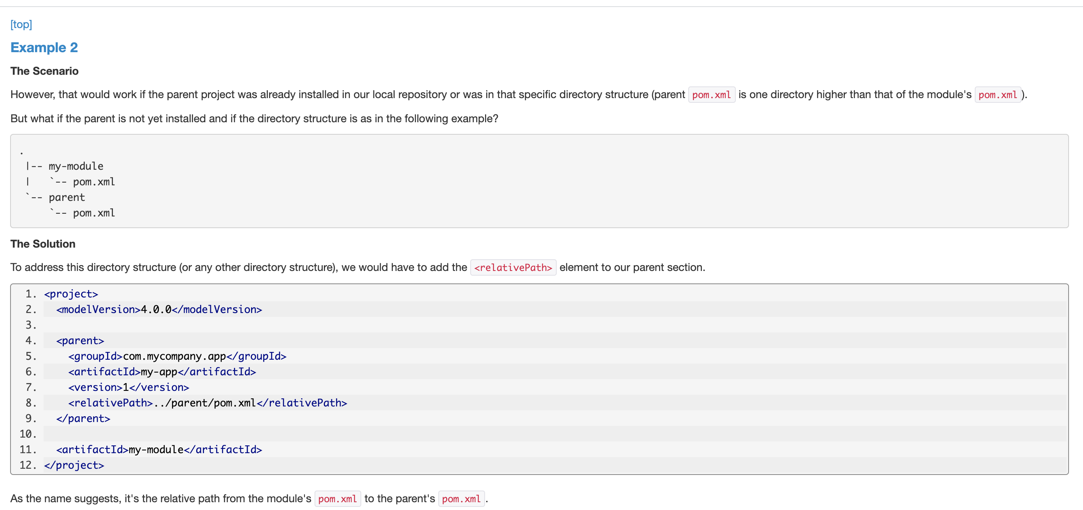

Maven Project aggregation:

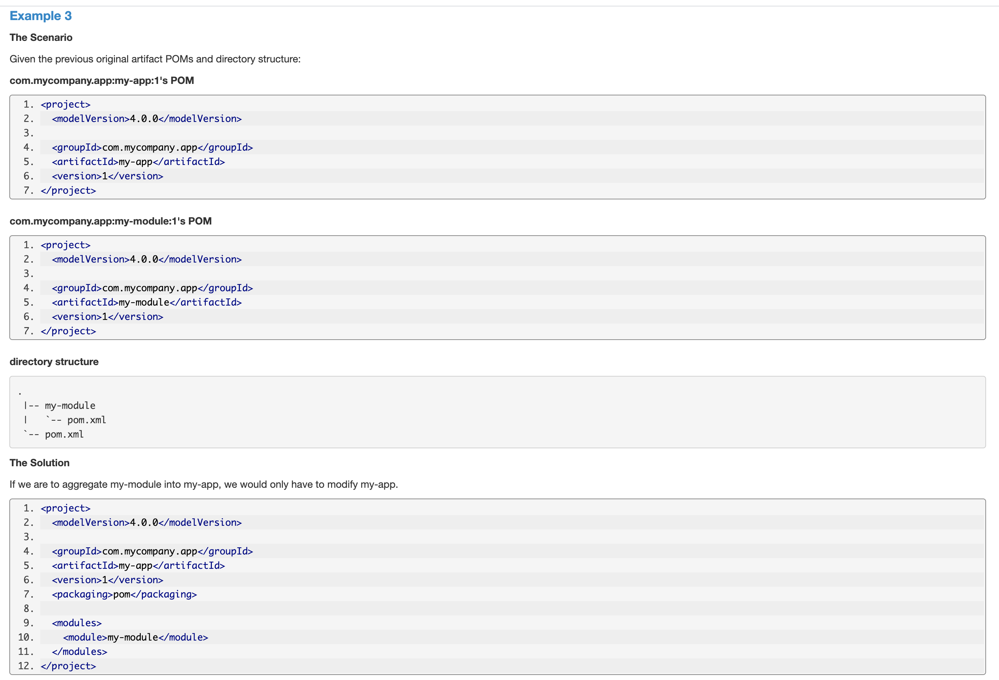

**Project Interpolation and Variables**

One of the practices that Maven encourages is *don't repeat yourself*. However, there are circumstances where you will need to use the same value in several different locations. To assist in ensuring the value is only specified once, Maven allows you to use both your own and pre-defined variables in the POM.

For example, to access the project.version variable, you would reference it like so:

1. <version>${project.version}</version>

mvn archetype:generate -DgroupId=com.howtodoinjava -DartifactId=HelloWorldApp-ear -DarchetypeArtifactId=maven-archetype-quickstart -DinteractiveMode=false